**EFM8BB1LCK BLDC Quick-start Guide**

This quick start guide aims to demonstrate the capabilities of the EFM8 Busy Bee Low Cost 8-bit MCU starter kit for operating BLDC motors. Code was ported from the C8051F850 BLDC reference design kit to allow the EFM8BB1 to power and control the power train board MCRD-PWR-NLV-F85X.

Kit Contents

* 1 x EFM8BB1LCK
* 1 x Powertrain Board: MCRD-PWR-NLV-F85X
* 1 x BLDC Motor: Turnigy 450 Series 3800 kV Brushless Outrunner Helicopter Motor
* 1 x Motor Mount Board
* 1 x 12 V, 5 Amp Universal Input Power Adapter
* 1 x micro USB cable

For reference to operation specs, theory of operation, system implementation and code review, refer to the document AN794 from Silicon Labs

The unique features offered by this implementation to the 8 bit MCU for BLDC motor operation are:

* PWM synchronized blanking of comparator for BEMF Zero-Crossing Detection
* Automatic PWM duty cycle reduction to limit motor current during startup
* Hyperdrive mode to increase the maximum speed of some motors

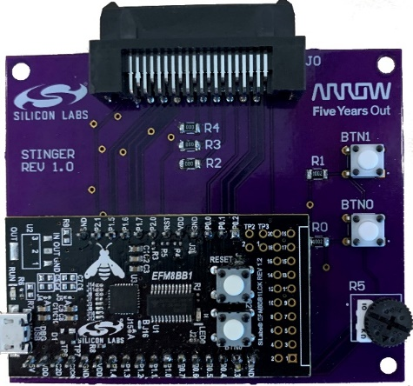

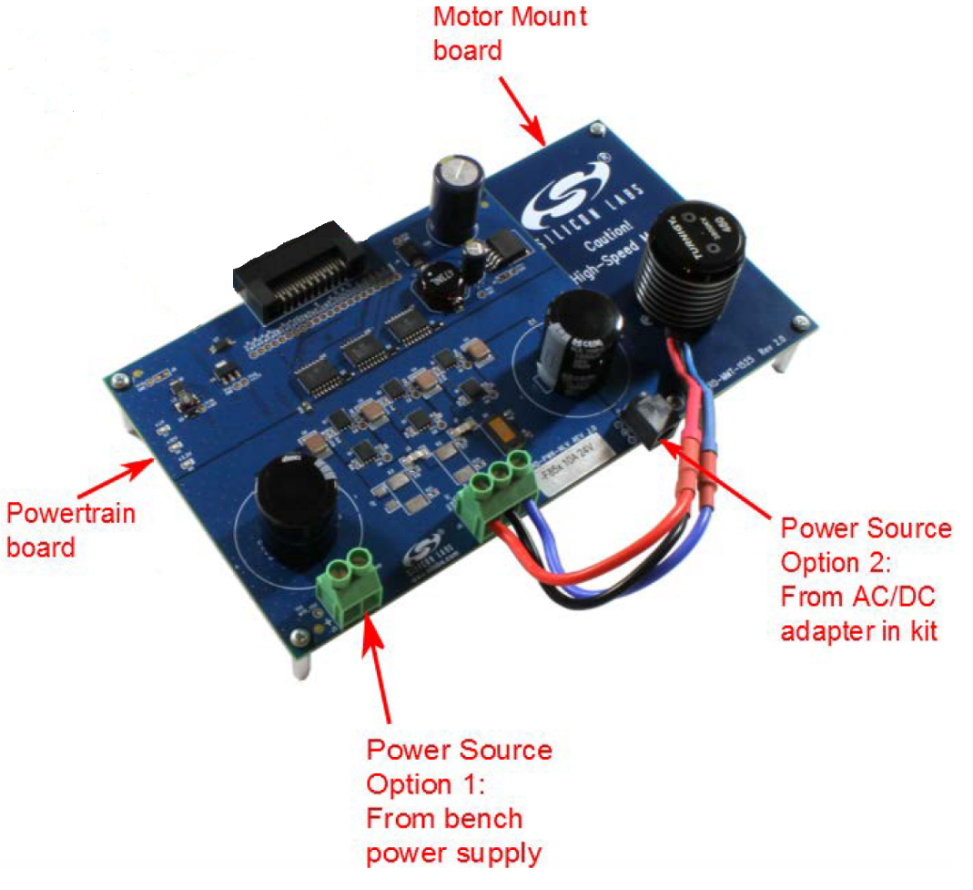





1. **Setup Instructions**

Firstly, there are hardware changes that need to be made on the EFM8BB1LCK. Under the boards default configuration, btn0 is hard wired to pin 0.2. Although buttons are needed for this demo, pin0.2 is required to run the program. Therefore, the connection from the pin to btn0 needs to be cut. This is done by de-soldering jumper j2.

The interposer board has all the necessary hardware for operation. Users will be required to solder male 0.1-inch header pins to the bottom of the EFM8BB1LCK.

At this point you will need to download and import the BLDC motor code from the Github repository shown below:

<https://github.com/ArrowElectronicsESC/EFM8BB1_BLDC_PORT>

Once installed and properly imported into Simplicity Studio, build the code, debug and program the board.

1. **Connector Diagram**

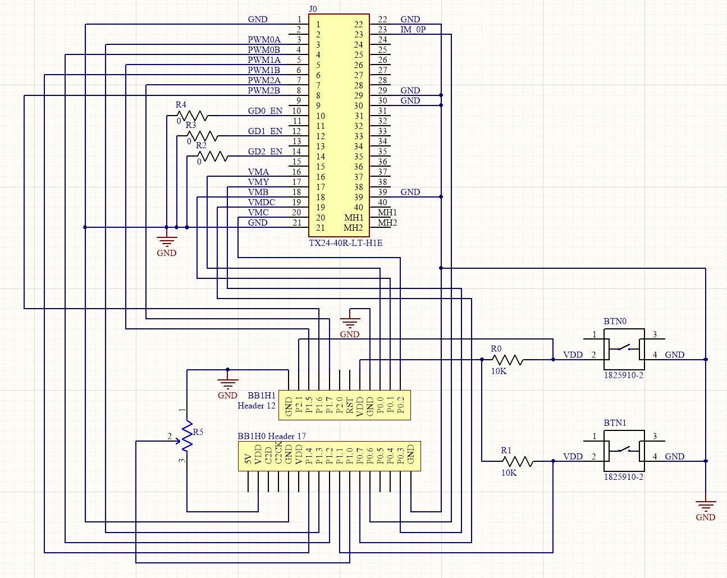

Figure 2. Stinger Imposer Board Schematic

Figure 1. Stinger Interposer Board Schematic

1. **Operation**

* Connect the AC/DC Adapter to the Powertrain board, and power up the board.
* Connect the EFM8BB1 to the Stinger interposer board
* Connect the EFM8BB1 to your computer (or to a power supply)
* Find the potentiometer connected to the MCU board and rotate it fully clockwise to prepare to spin the motor at minimum speed
* Connect the Stinger interposer board to the Powertrain board
* Press the BTN1 (Start/Stop button) to start spinning the motor
* Adjust the potentiometer to control motor speed
* Press the Start/Stop button to stop spinning the motor
* Press BTN0 to change the direction with which the motor spins

Important: The MCU reset button can also be used to stop the motor at any time